Vermot-Desroches Matthias

Rapport de séance n°13

During this session, I connected cables in order to use all the motors at the same time.

I started by using luster terminal to assemble all the cables from one side into one. After speaking with Mr Masson, we decided that using terminals with the luster terminals will be better.

Here is a picture of the terminals with the cables:

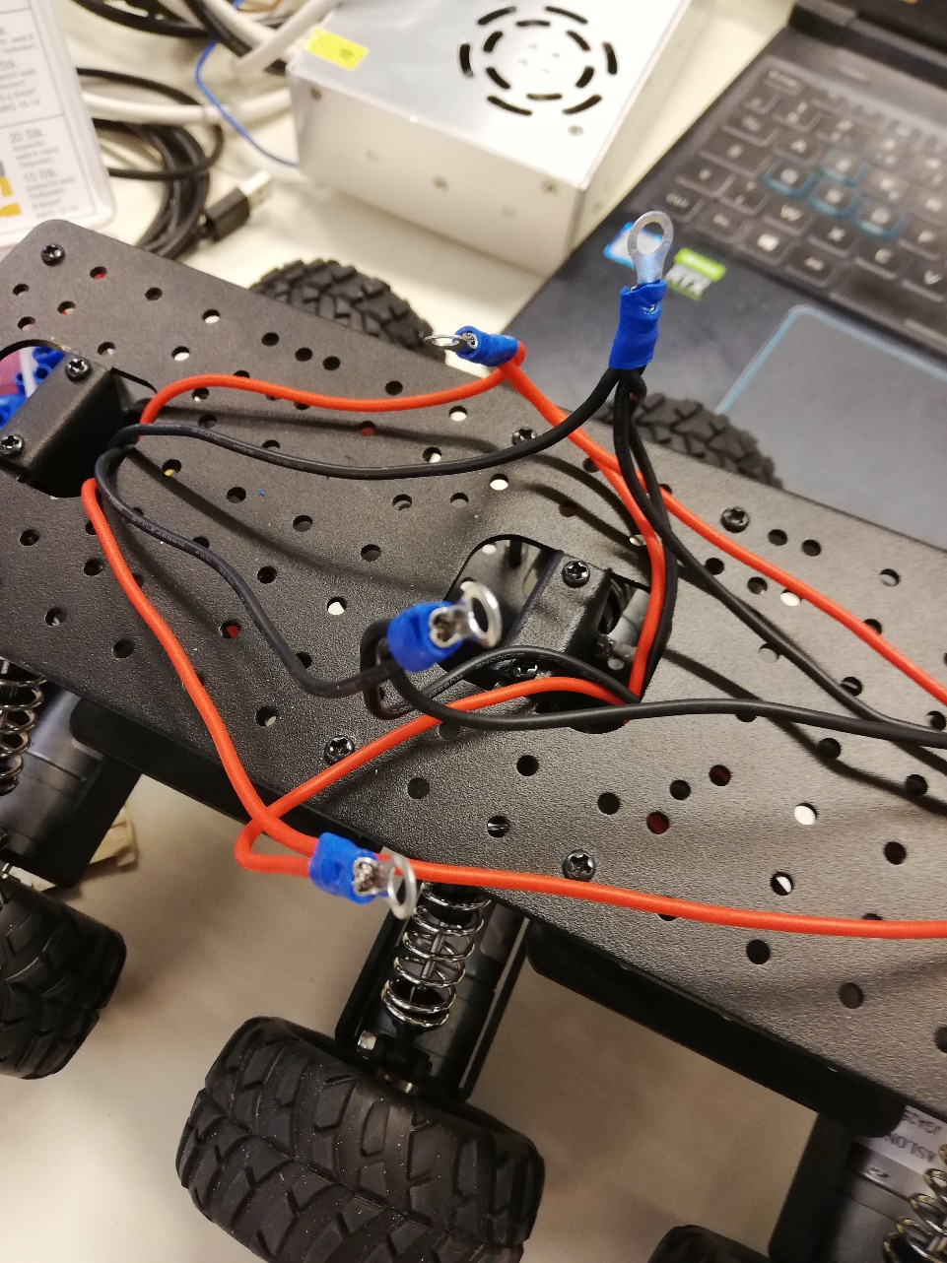

Here, you can see that I used 4 terminals , 2 for each sides, one for the plus, one for the minus.

After that, I put the terminals with the luster terminals on the frame. Here is a picture of the ensemble:

Then, I used 4 other cables to connect the luster terminal with the motors’ driver:

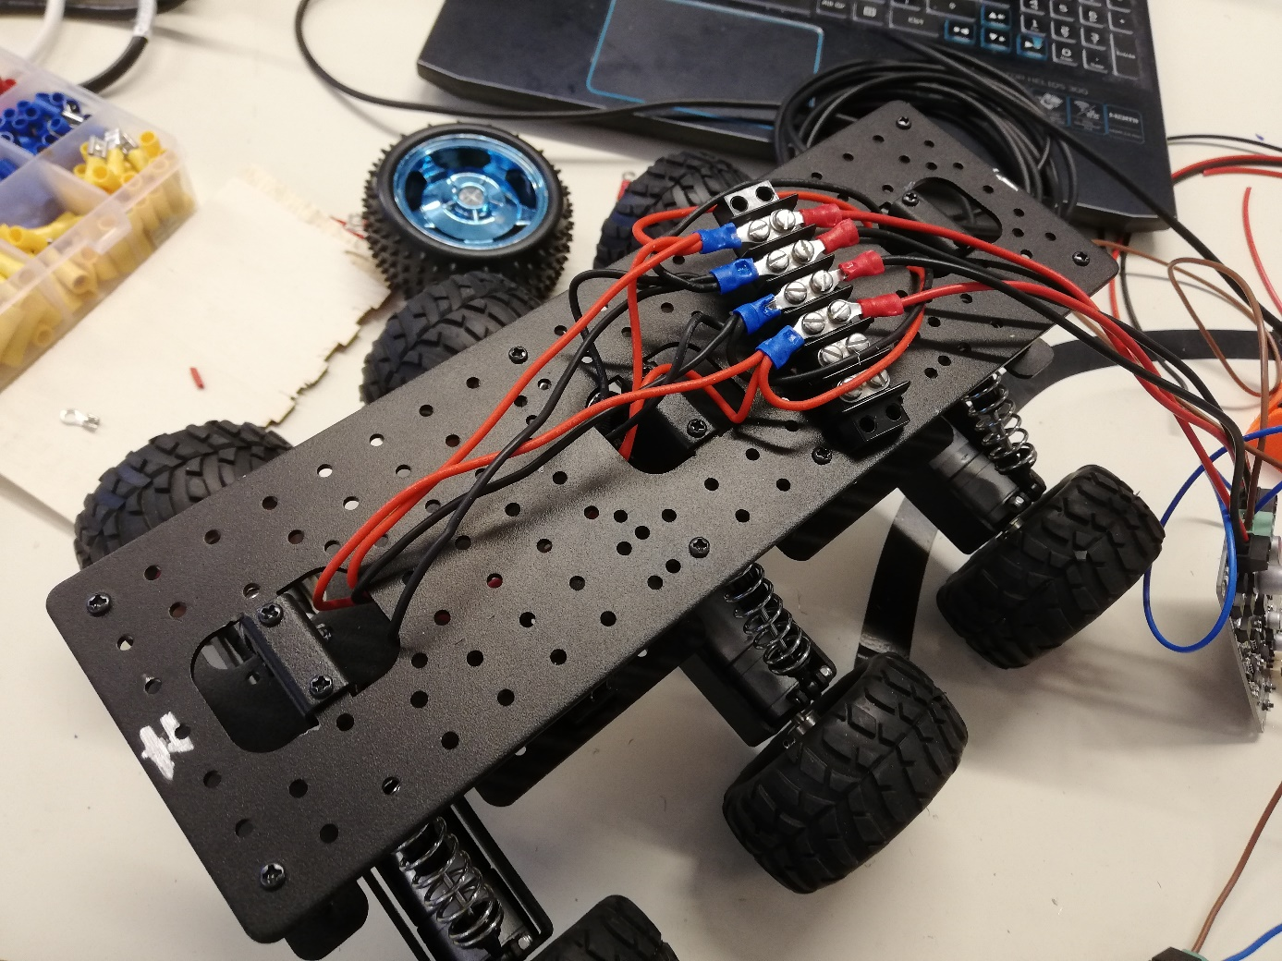

After struggling with the cables’ tightening for a while, I managed to connect everything correctly, at least I thought I had, and then started the program. The program worked, the motors’ speed increased and decreased when needed… for 4 motors out of 6… The other 2 were either not working or in the opposite direction (anti-clockwise).

At first, I did not understand where these problems came from, because I believed that everything were right in the cable’s connection. But I discovered that I indeed made a mistake, I inverted 2 cables connection, thus messing up everything.

Mr Peter helped me removing the terminals to fix my mistake. Then, the program worked as it was intended to.

I spent the remaining time of the session thinking about how to put all the electronic stuff on the frame, as the driver and the frame were in metal, so they could not come into direct contact.

I decided that I would use some plastic plate, here is a rough picture of how it will be:

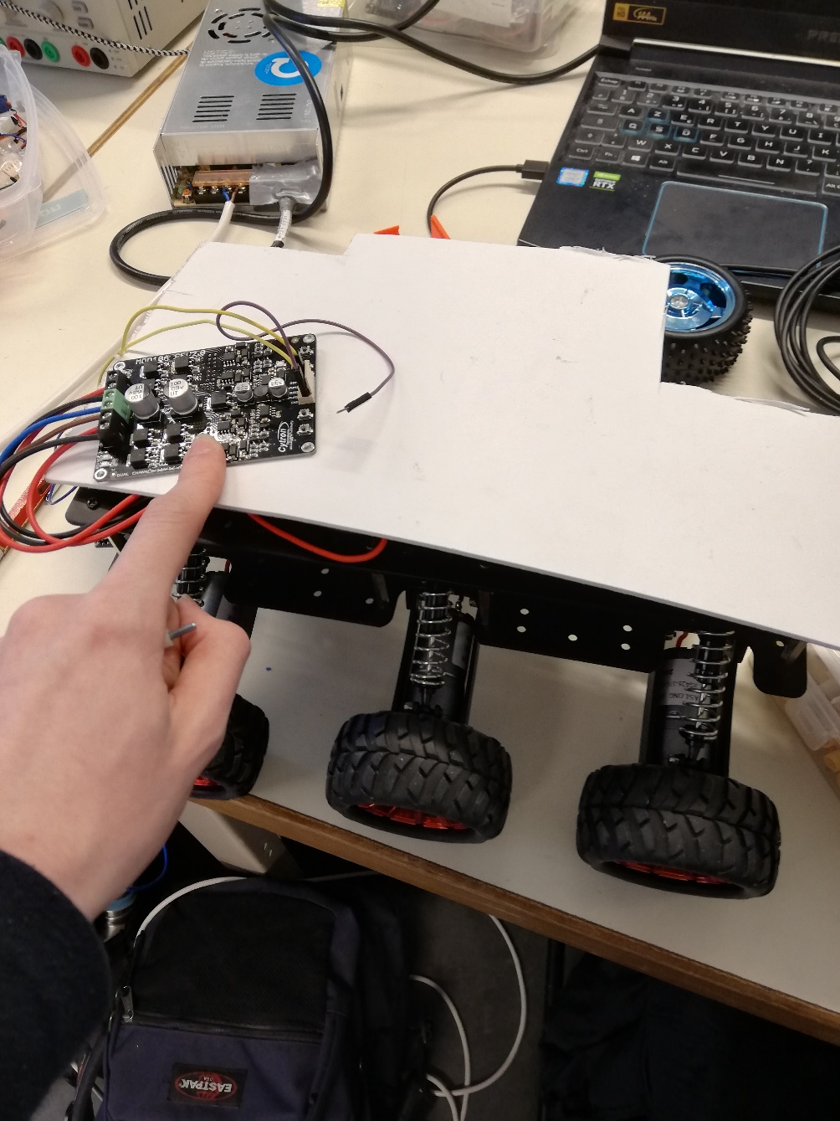

The plastic plate will be screwed a little bit above the frame. It is a temporary state, later we will make a new “floor” on the frame to put all the electronic on.